Mohamed Shamin Ali

English Composition I

July 13, 2020

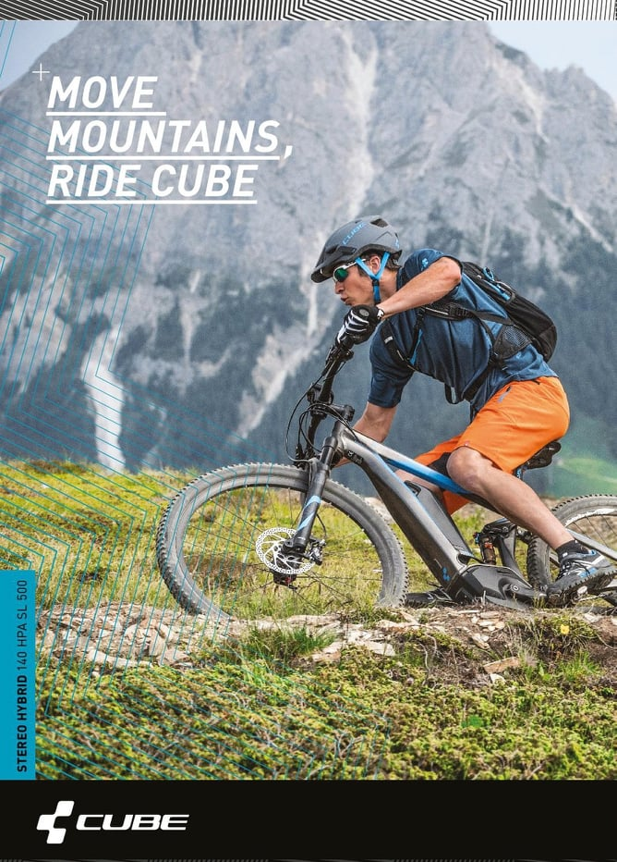

Advertising is a multi-billion-dollar industry, and advertising and its related subjects are taught in universities. Digital marketing experts estimate that most Americans are exposed to around 5,000 ads per day, and the number can double based on the area a person lives and commuting preferences. The huge exposure to advertisements has a dramatic effect on the consumers, both positive effects, such as the promotion of awareness, and negative effects, such as being tricked into purchasing a product. Since the advertising industry is so prolific and shows no signs of slowing down, one can learn to analyze advertisements so that the messages behind the ads are brought out into the open.

Can you make this thesis statement more focused and specific? For example, “by analyzing the various design components of an ad, such as x, y, and z (e.g., imagery, text, etc.) one can expose the hidden messages being communicated to consumers.” Or something like that!

This advertisement of a hybrid bicycle targets men first and foremost because of the man riding the bike, but the product could also be used by women. This is evident through the focused male rider on the bicycle. The stableness of the bike in the hard terrain convinces the viewer that the bicycle can withstand any surface. One of the most eye-catching features of the bicycle is its hybridness; the battery is visible mounted to the frame and the motor pedal. A hybrid electrical bike will give the rider an extra boost when climbing the hills, or the ability to just ride it on the battery while the rider rests. Although that is the case, an e-bike weighs more than ordinary mountain bikes due to the battery and other components.

A closer inspection of the bicycle reveals its hydraulic brakes and thick tires with more surface area, which invites the viewer to think about the slogan “Move Mountains, Ride Cube.”

The text in the advertisement, “Move Mountains, Ride Cube.” suggests there are no impossible challenges with the Cube bicycles. This will surely invite the viewer to believe that the cube hybrid bike is needed for a great mountain ride adventure, although I am skeptical that a hybrid bike is a requirement for a great ride. The bottom left corner of the advertisement mentions the exact model of the bicycle, “STEREO HYBRID 140 HPA SL 500,” in case one wants to find more information about the specifications or order the bicycle.

Often, logos are placed on the top of the advertisements, but the designers bend the rules and placed the logo at the bottom, because the picture of the bike draws the attention to the lower third of the page. This is a clear sign that the advertisers want people to make an instant connection between brand, product, and quality of life. The C is made up of cubes, and the text “CUBE” is laid next to the C.

The next thing appealing about this advertisement is the rider. The rider is placed at an angle to convince the audience of the stableness of the bike. The advertisement indirectly promotes biking apparel and gear the rider is using. The rider is wearing a grey color helmet that goes along with the color of the bike. It clearly proves that the manufacturers recommend riding safely, and helmets are crucial to protect one from head injuries, which are frequent while riding bicycles.

Moving on, the rider is wearing goggles to protect the eyes from dust and shooting rocks, riding gloves that promote a firm grip on the handlebars, and the shoes protect feet and fingers while giving the rider an excellent foot grip on the pedals which makes the rider a textbook example of riding the bicycle safely. The rider is also wearing a lightweight t-shirt and shorts, which promotes airflow and allows the rider to perform better on it.

Often, the water bottle is mounted to a cage on the bike's frame, but in this CUBE STEREO HYBRID bike, the battery occupies this space, and the rider in the image is wearing a backpack in which the rider can carry water and snacks.

The next thing catchy about this advertisement is the terrain and mountain. The bicycle is set on a rocky pavement terrain surrounded by moss and grass. It looks adventurous but dangerous at the same time, and the bike is portrayed as one that one can trust needed for such a trail because the moss makes it easy to lose control. A good set of brakes and tires are required for a path like this.

The advertisement relies on a grey and black mountain background, which makes an excellent composition for the image, and perfectly matches the color of the bike, which is also grey. This shows the viewer of the advertisement that the bike is indeed ready for mountains and adventure.

A close analysis of this advertisement reveals this advertisement targets adventurers and bikers in particular. The ad tells a story of adventure and challenges, and there is no big challenge a CUBE HYBRID cannot cross. Riders are also encouraged to take safety precautions and ride safely.

-801 word –

Think About Your Writing:

1. What is the significance of your essay? Why should your reader care about what you have written? (2-3 sentences)

I believe readers will care about this essay because of my thesis statement. I informed the consumers that they need to hack the advertisement to find the meanings behind it and the positive and negative impacts it has on buyers.

1. What areas of your draft do you think will benefit most from revision? (2-3sentences)

I had a difficult time explaining the advertisement features because there is too much packed in even though the ad is simple. I didn’t want to expand on everything but focus on central concepts and ideas.

1. Consider the strengths and weaknesses of your writing. How can you capitalize on your strengths and improve on your weaknesses in future essays? (3-4 sentences)

I think I am good at developing and presenting the thesis statement and research; however, as a nonnative speaker, I need to work on my vocabulary. Also, improve the flow of the essay and organize the essay better. I always struggle with conclusions, and reading essays written by other native speakers will enhance my future essays.

|  |  |  |
| --- | --- | --- |
| ***Touchstone 3 Rubric and Feedback*** | | |
| ***Rubric Category*** | ***Feedback*** | ***Score (acceptable, needs improvement etc.)*** |
| **Image Analysis OR Extended Definition** | Includes some analysis of the design choices made in the advertisement, but focuses a lot on description without fully connecting those design choices to “meanings behind it and the positive and negative impacts it has on buyers.” | *Acceptable* |
| **Working Thesis** | Has an acceptable working thesis, though a bit unclear or unfocused. | *Acceptable* |
| **Organization** | Includes all required components; try to consolidate your body paragraphs and make sure that each one covers one main topic. | *Acceptable* |
| **Style and Tone** | Demonstrates generally effective word choices; establishes a primarily objective tone. | *Proficient* |
| **Focus** | Details are relevant and support the purpose of the essay. | *Proficient* |
| **Conventions** | Occasional errors in grammar, punctuation, etc. | *Proficient* |
| **Think About Your Writing** | Demonstrates thoughtful reflection. | *Proficient* |
| ***Overall Score and Feedback: 7/10*** | | |